

**RABIAMMAL AHAMED MAIDEEN COLLEGE FOR WOMEN , THIRUVARUR**

**TEAM ID : NM2023TMID16474**

**TEAM LEADER : A.NASRIN BANU**

**TEAM MEMBERS : M.AFRIN BEGAM**

**A.KOKILA**

**S.SAKTHIYA**

**A.L.SIVA AGALYA**

**S.SUMAIYA**

**S.VEDHAVARSHINI**

**PROJECT TITLE : A Data-driven Exploration of Apple's iPhone Impact in India**

* INTRODUCTION :

Our projrct is Exploration of apple’s iPhone impact

in India.Involving the collection and analysis of a wide range of data including information about the impact of apple iPhone in India and other details.

* PROBLEM DEFINITION & DESIGN THINKING

Empathy map

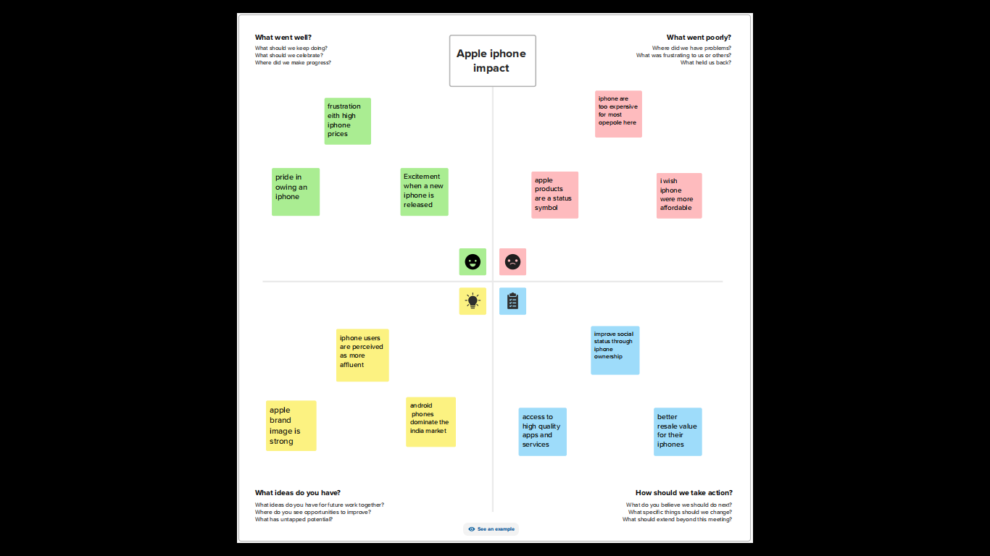

Ideation & Brainstorming Map:

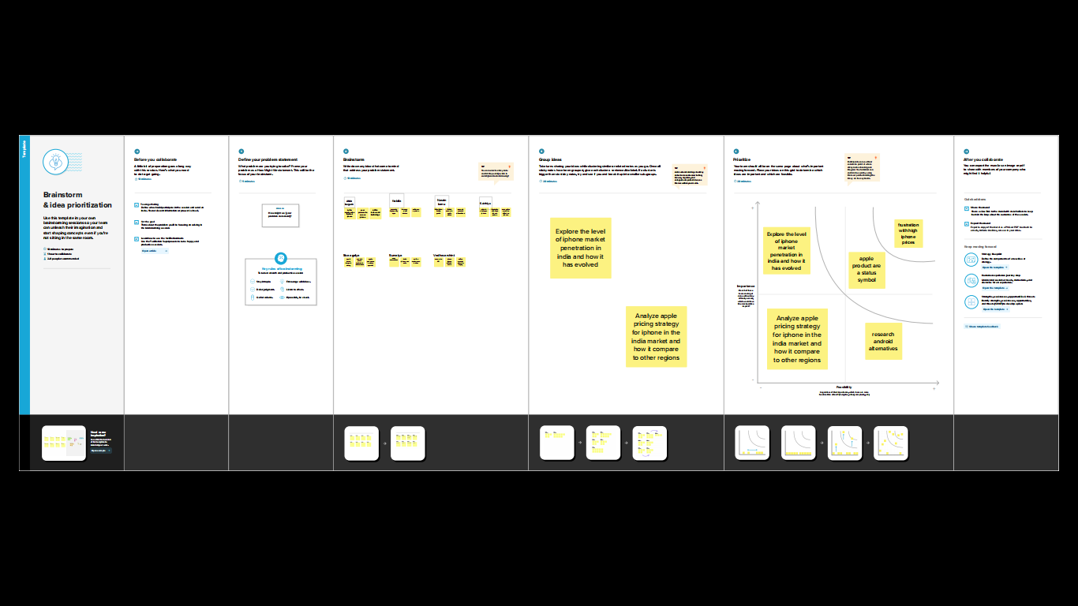

* RESULT :

Final finding (output) of the project along with screenshot.

MODEL SPECIFICATION:

The analysis of the flip-kart_smartphones contain the model,which processor are used,rear camera and original price of the apple iPhone.

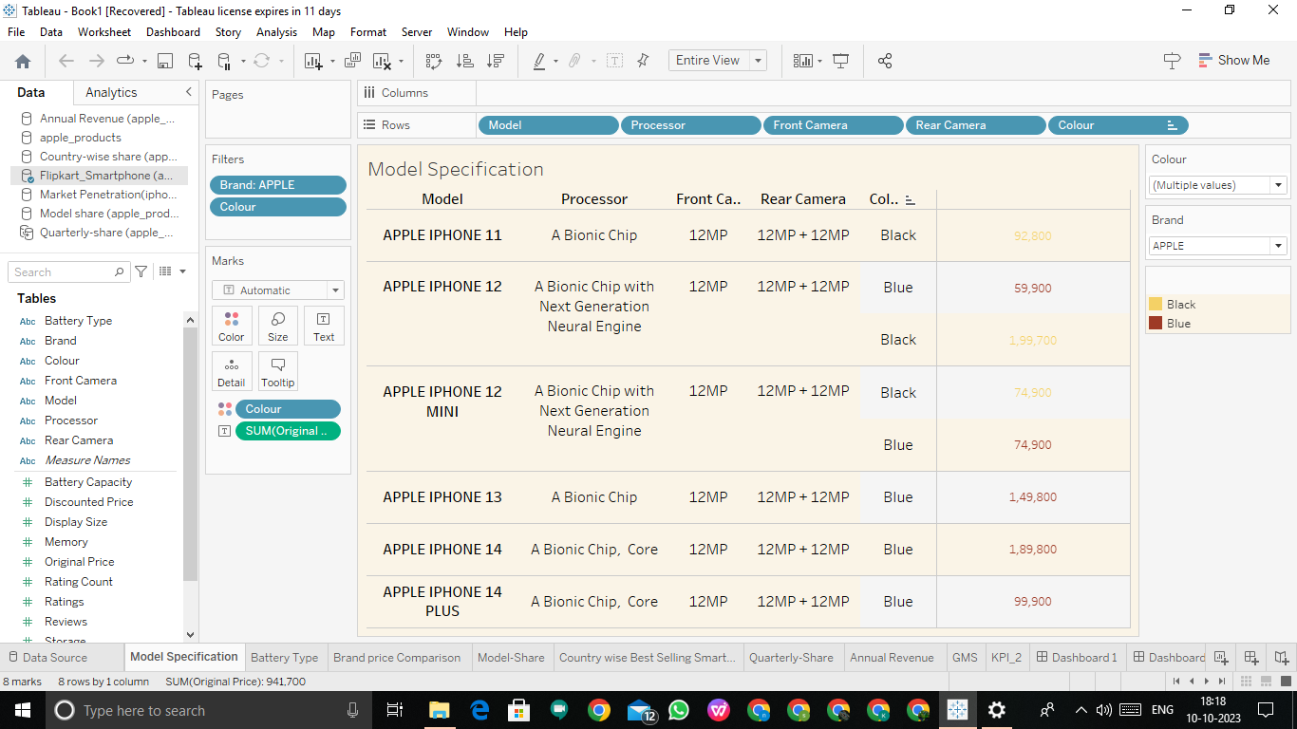

BATTERY TYPE DISTRIBUTION :

In the analysis Lithium battery has a highest price such as 35k compare to other batteries.

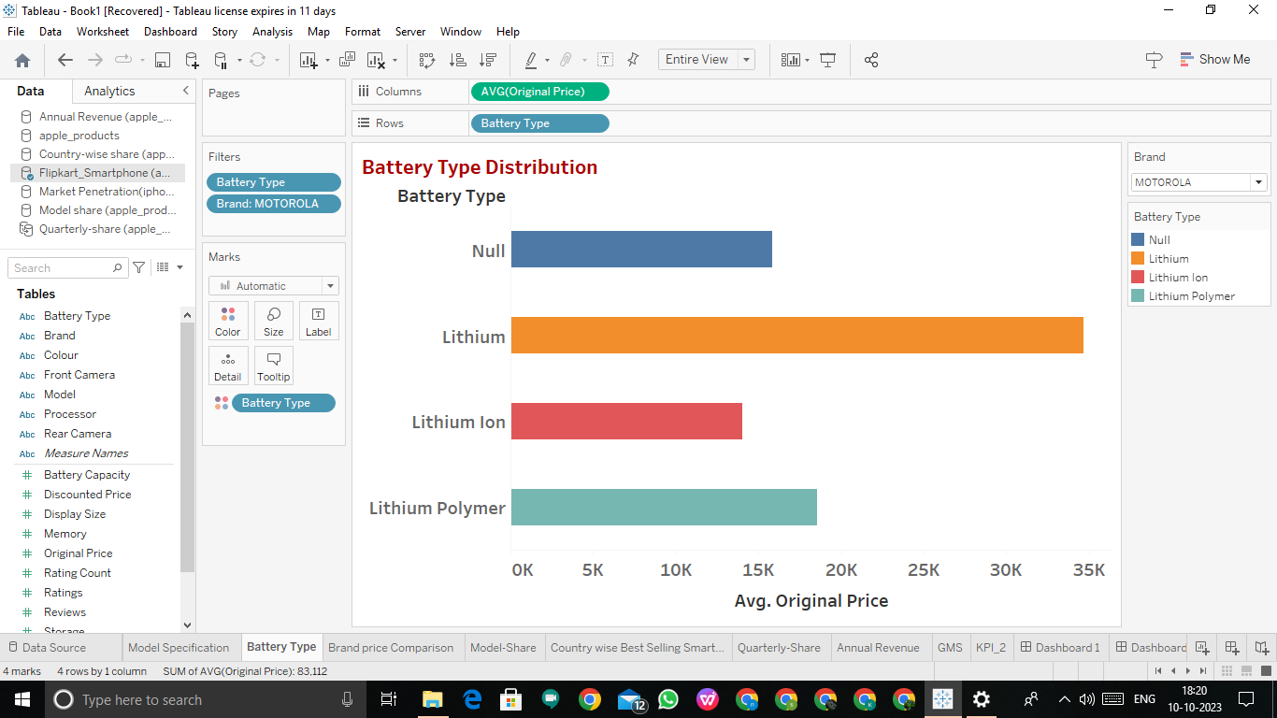

BRAND & PRICE COMPARISON :

Apple phones are compare to other company models with the price and memory.Companies like Oppo,Realme,Vivo and etc…..

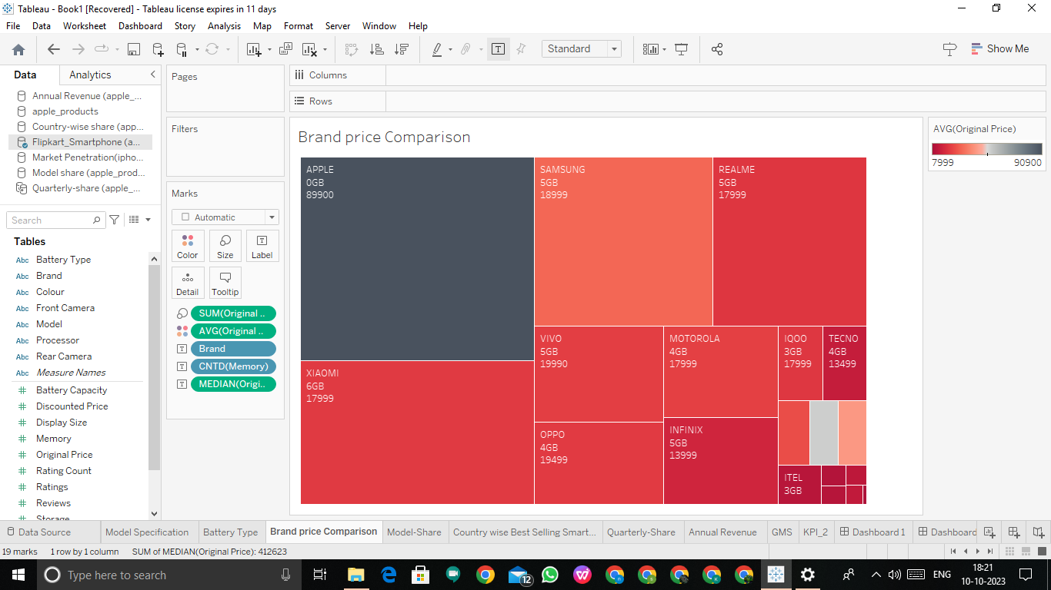

MODEL-SHARE :

Apple phones has a various models based on the internal storage,RAM,ROM,camera quality and others…

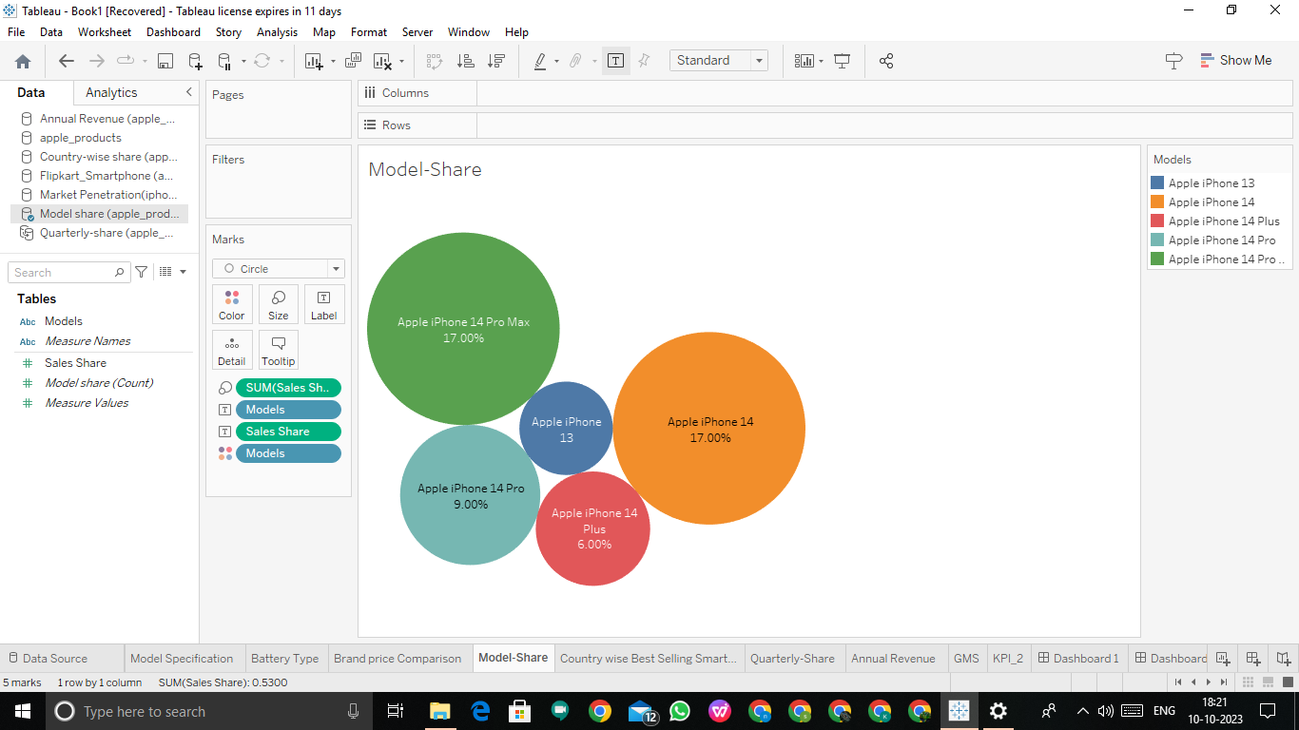

COUNTRY WISE BEST SELLING SMARTPHONES :

In India apple iPhone has a 3.00% of sales share .Apple iPhone has third place in sales-share.Oneplus has the first place in sales-share (4.00%) of India.

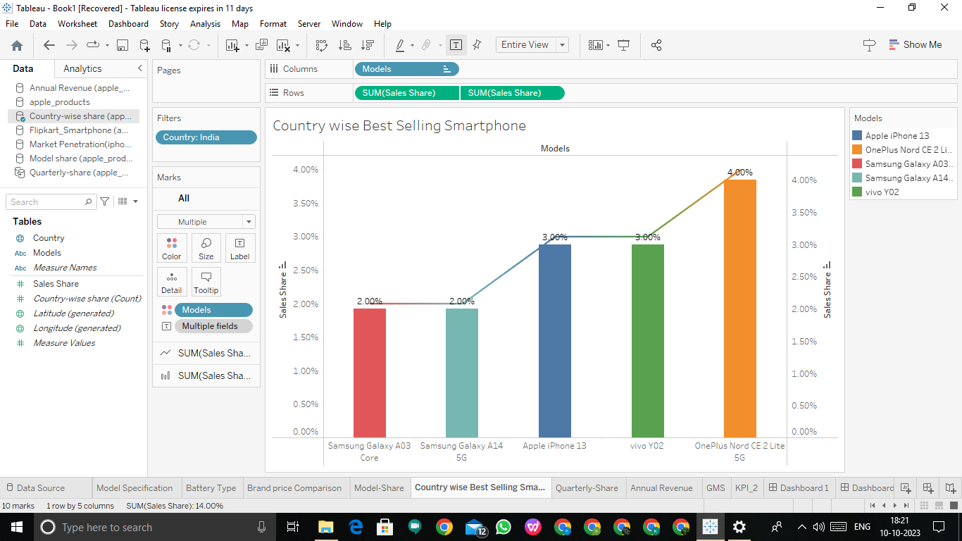

QUALITY-SHARE :

In 2018 we will analysis the quality-share of mobile company models. Thw year will be change manually.

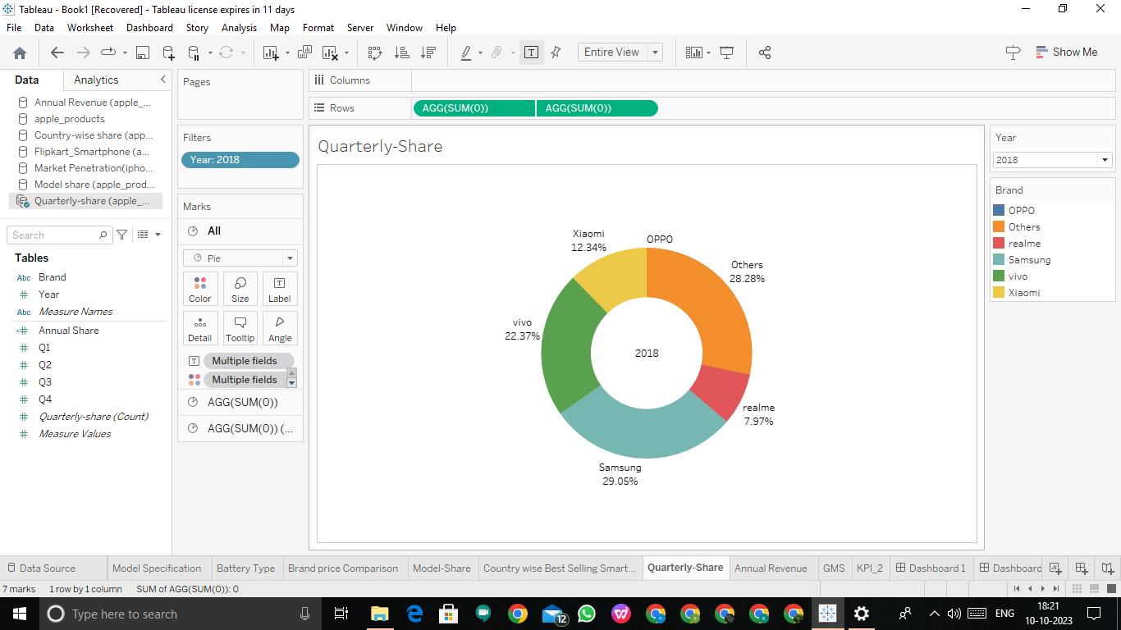

ANNUAL REVENUE:

Apple iPhone sales generated $ 205 billion revenue for Apple in 2022, more than Microsoft’s total revenue. It sold 232 million iPhone units that year.

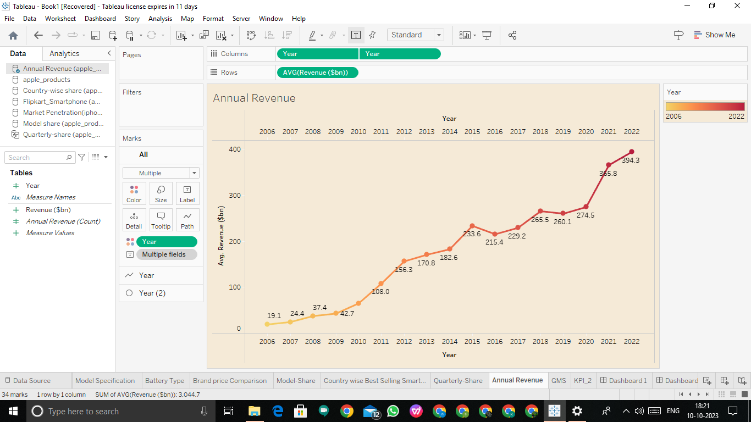

GLOBLE MARKET SHARE :

Although the iPhone isn’t far behind in the competition , it is yet to scale-up it’s marketing strategies and policy formulations for Indian audience.

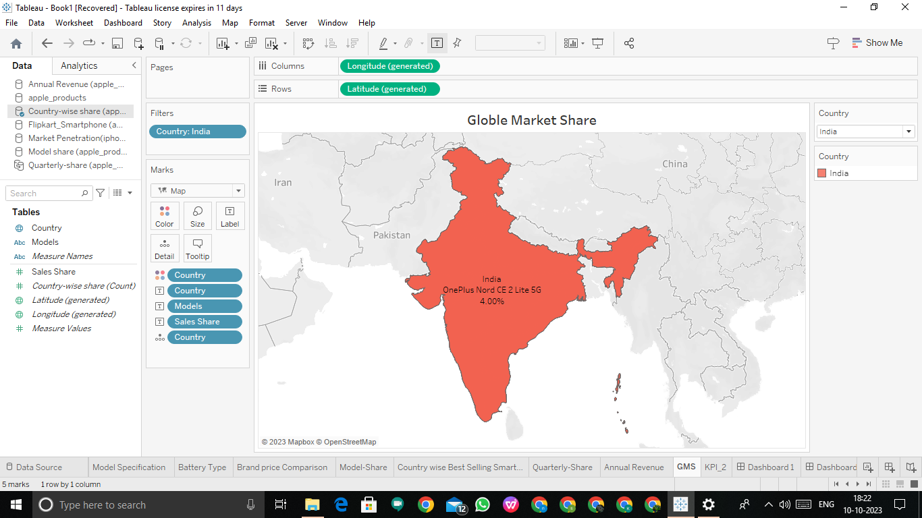

DASHBOARD :

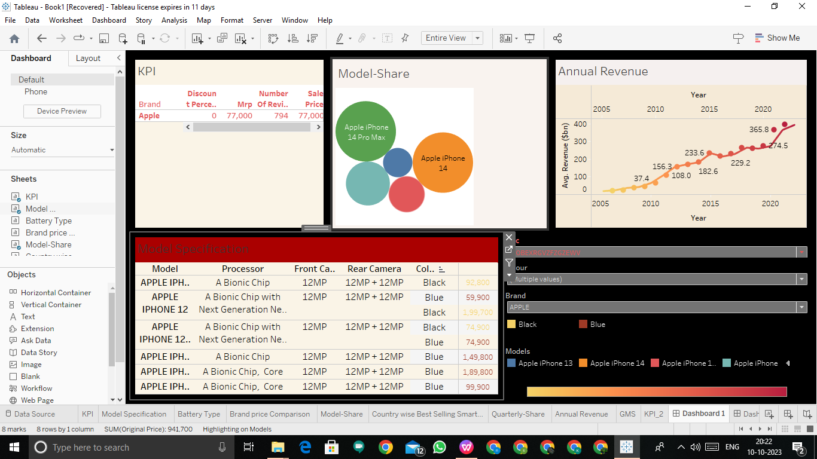

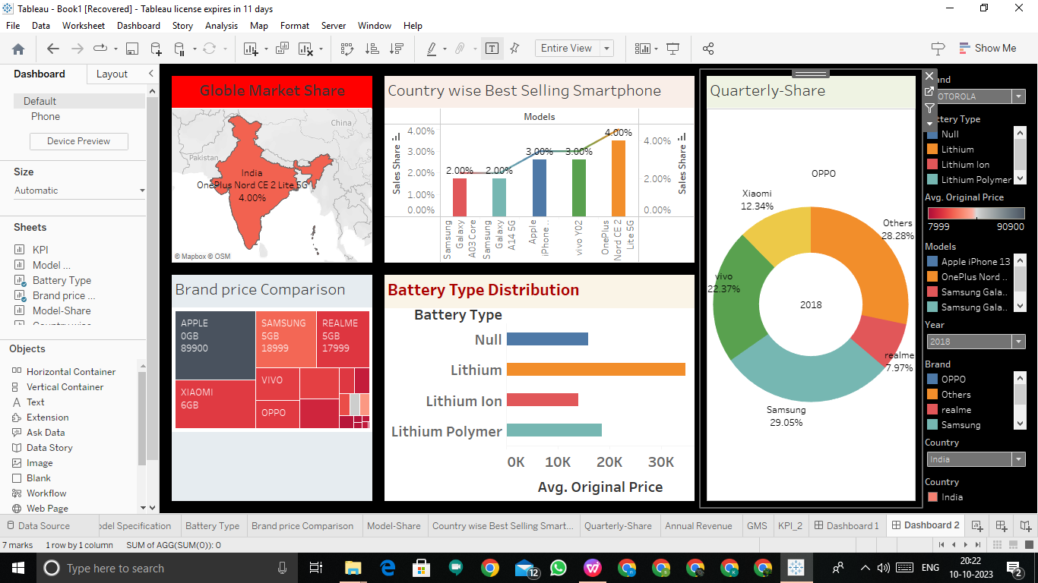

STORIES :

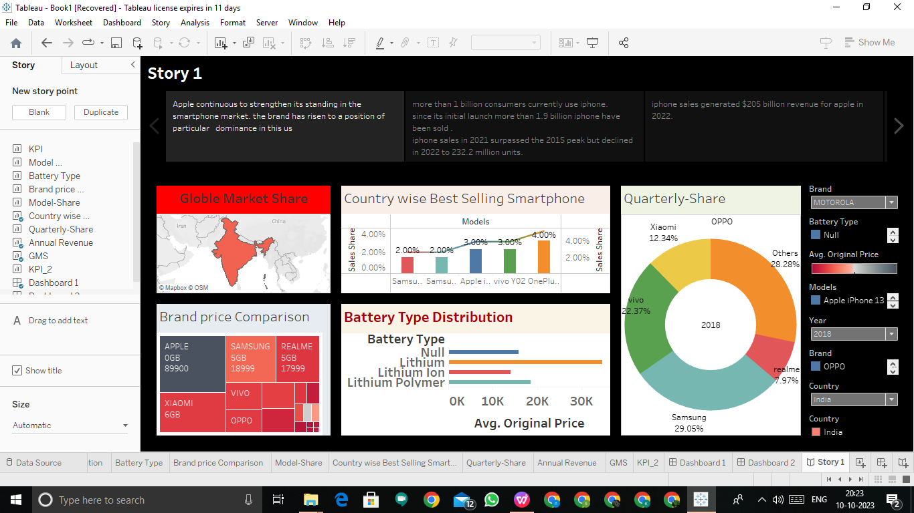

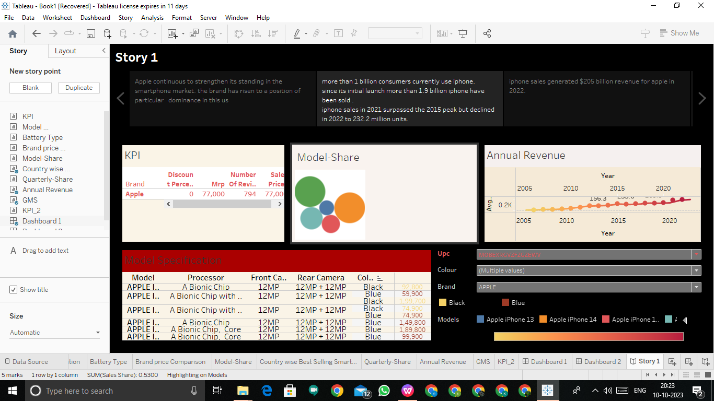

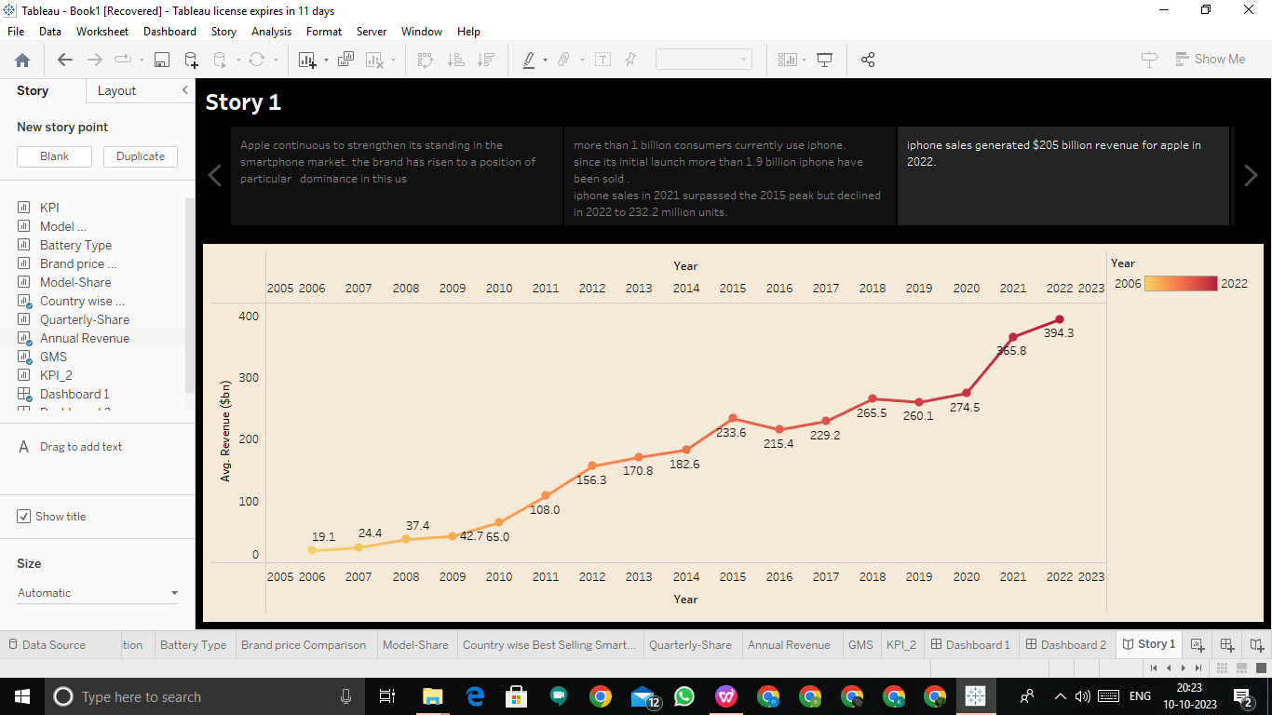

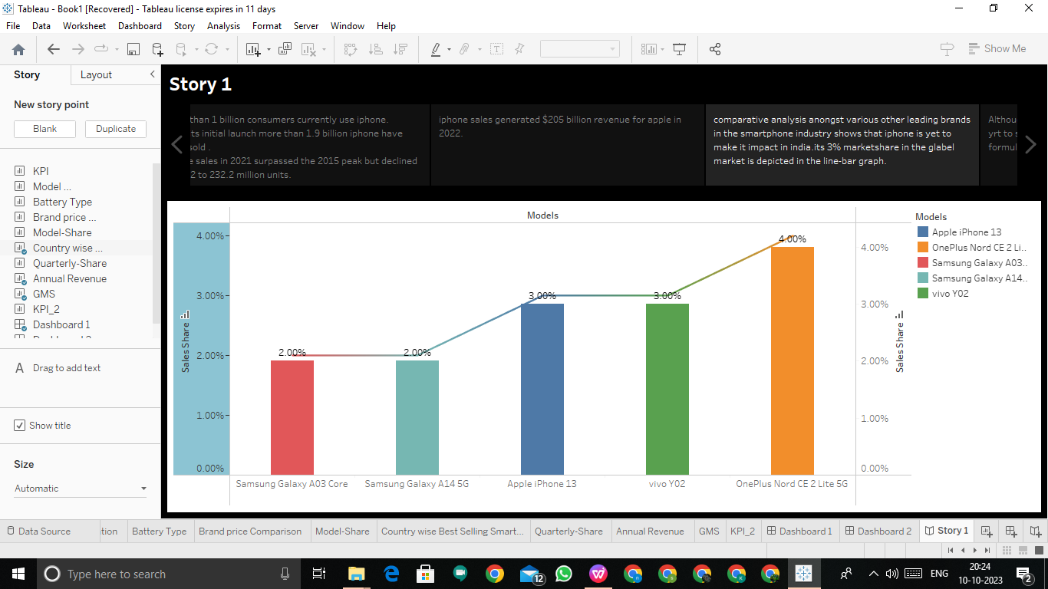

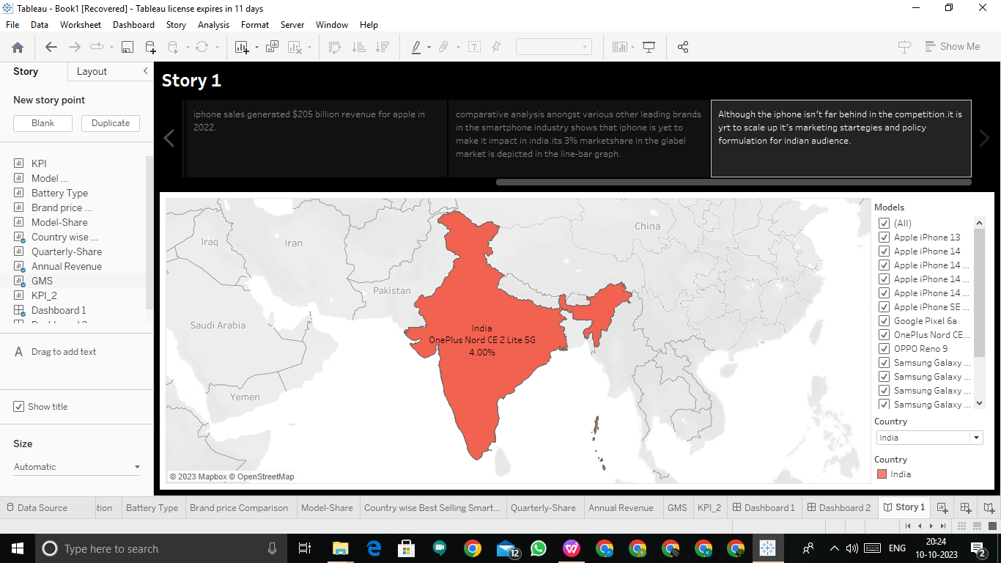

TABLEAU PUBLISHED SCREENSHOTS :

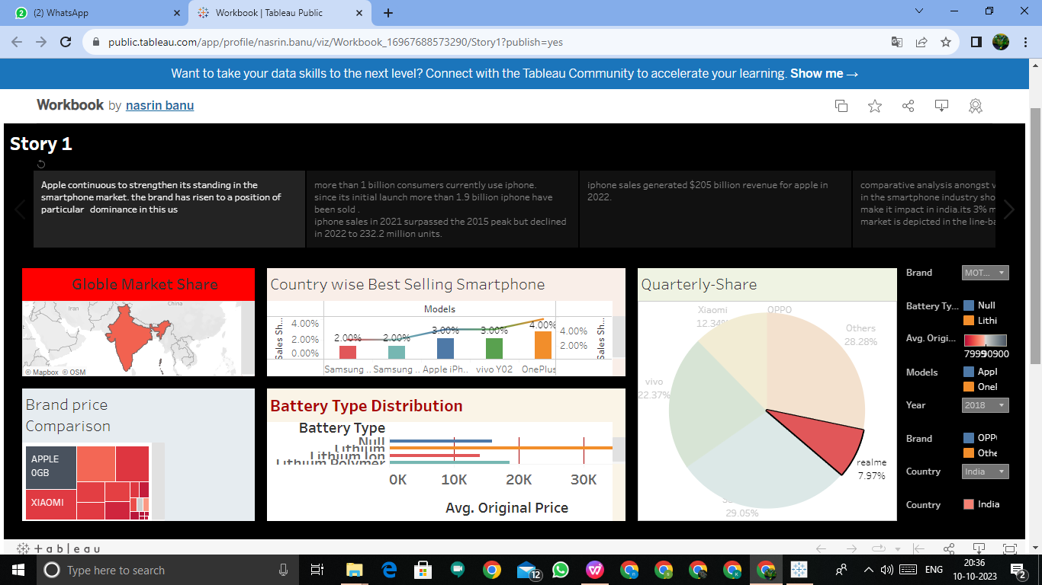

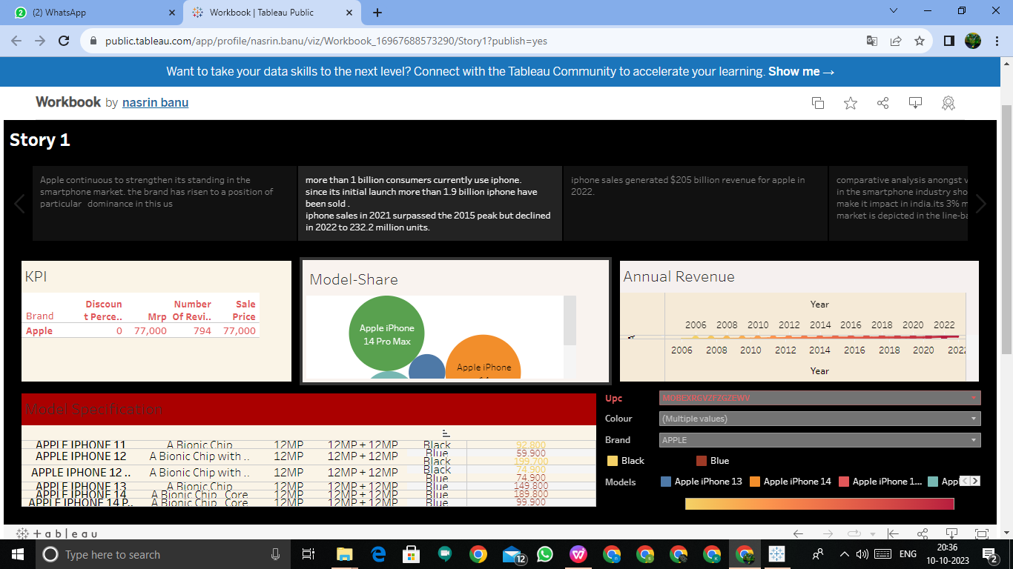

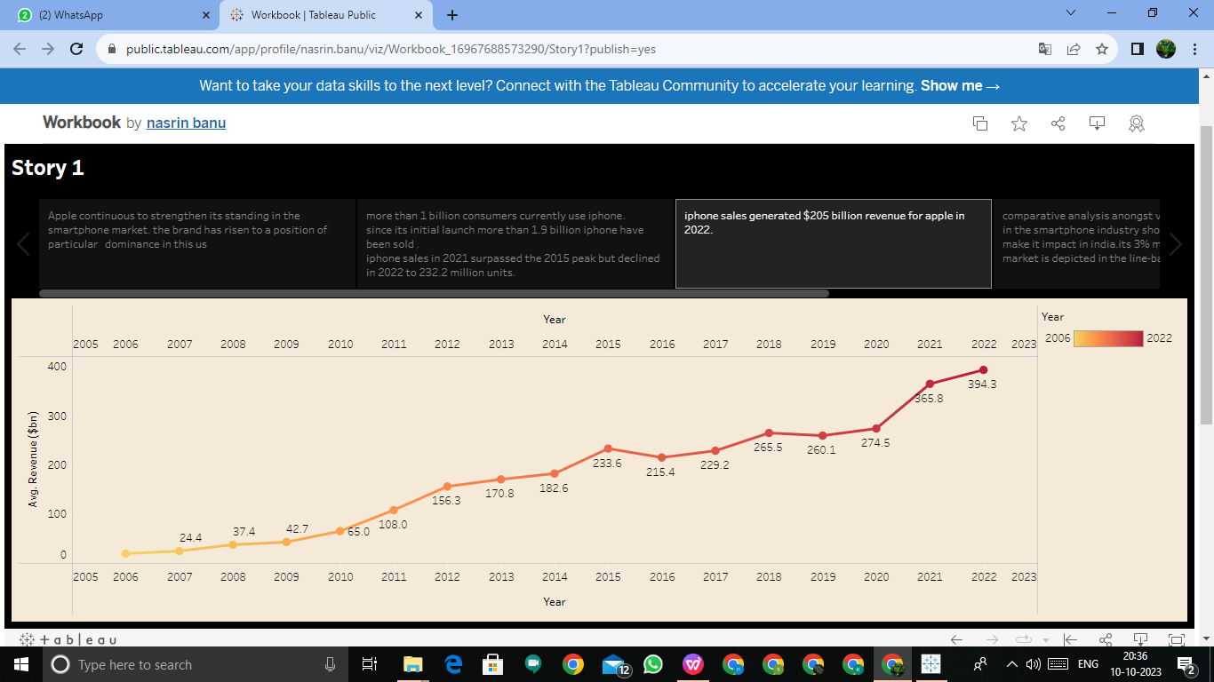

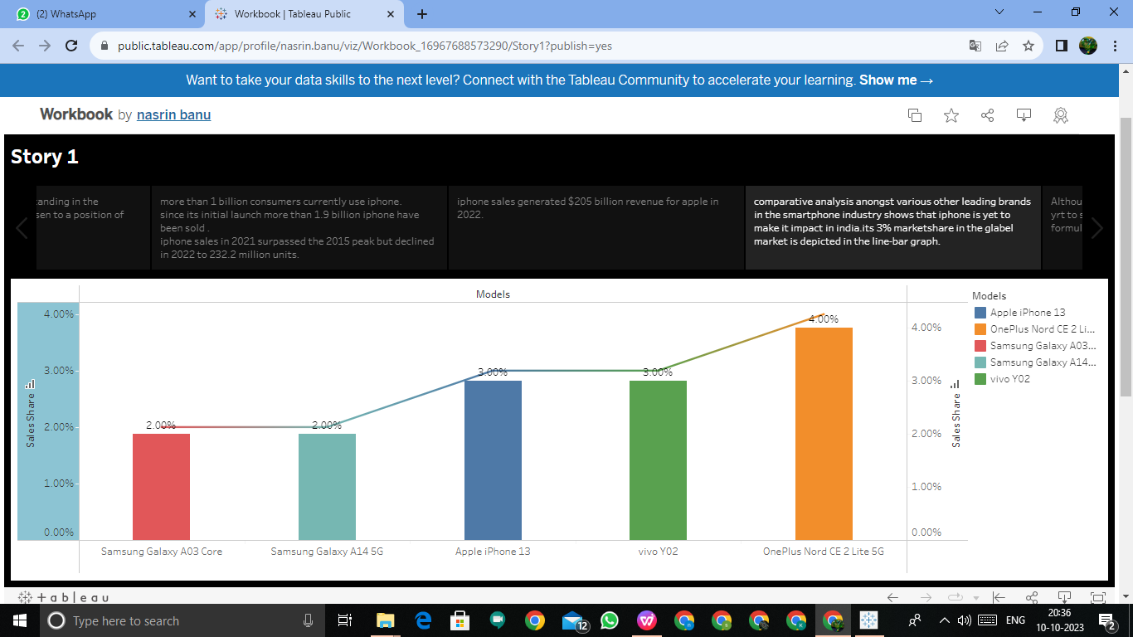

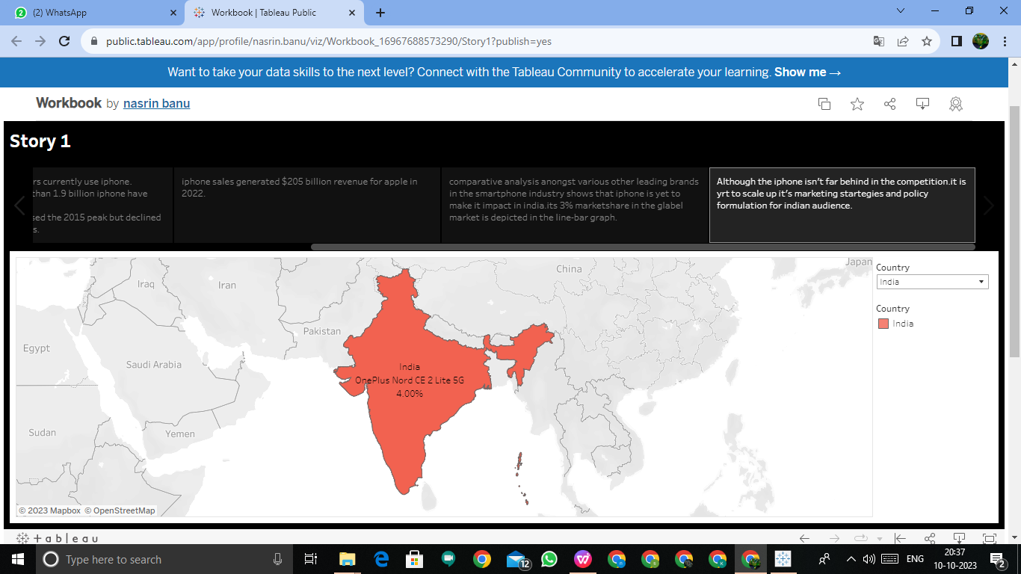

* ADVANTAGES & DISADVANTAGES :

ADVANTAGES:

* Better performance compare to android devices,apple phones offer better performance.
* The iPhone is better than android ,offering timely and instant updates to the users.
* Another advantage of apple iPhone over android is the ease of use.
* All apps available in the apple iPhone store go through strict checking.
* The family sharing feature also makes iPhone better than android.

DISADVANTAGE :

* Android phone dominate as more affluent.
* Limited access on the apple store.
* Software updates consuming too much data.
* Examine the economic impact of iPhone sales on Apple its suppliers and the Indian economy as a whole.
* iPhone are too expensive for most people here

“I wish iPhone were more affordable.”

* CONCLUSION :

This analysis gives the details to find the impact of apple iPhone in India.This help us to compare Apple iPhone to other company models. It’s sales-share less rather than other companies.I t was help us to analysis the impact of apple iPhone in India.

* FUTURE SCOPE :
* After android.iOS is the most extensive mobile operating system.It will have a market share of 277.73% in 2022,gradually increasing due to the popularity of iPhone.As the demand for Apple devices is rising the iOS development market is simultaneously booming.